BluLink OFFICIAL USER MANUAL

Geospatial & Link Analysis

Intelligence Workspace

Complete End-to-End Operational Manual & Analytical Field Guide

A comprehensive technical and practical guide for intelligence analysts, investigators, and authorized operators. Covers project management, entity profiling, relationship network mapping, military grid coordinates (MGRS), container grouping, multi-selection, and analytical reporting.

APPLICATION VERSION
BluLink Suite v1.2 (Production)
DEVELOPER
Rawnald Blu (RJG)



DEPLOYMENT INFRASTRUCTURE
Cloudflare Pages & D1 Serverless Edge DB
DOCUMENT DATE & CLASSIFICATION
October 2026 • Official Documentation

Table of Contents
TOC

Quick navigation across all chapters, modules, and operational cheat sheets.

01. Executive Overview & Architecture | Page | 2
02. Getting Started: Authentication & Projects | Page | 3
03. The Dual-Pane Workspace Interface | Page | 4
04. Entity Management & Profiling | Page | 5
05. Relationship & Link Analysis | Page | 6
06. Geospatial Intelligence & Mapping Engine | Page | 7
07. Grouping, Containers & Annotation Boxes | Page | 8
08. Multi-Selection, Marquee & Batch Operations | Page | 9
09. History, Undo/Redo, Import & Export | Page | 10
10. Keyboard Shortcuts & Operations Matrix | Page | 12
11. Operational Troubleshooting & FAQs | Page | 12

DOCUMENT USAGE TIP
This manual is formatted for both electronic reading and direct high-resolution printing. All keyboard shortcuts are enclosed in highlighted keys such as Ctrl + G for rapid reference in high-tempo analytical environments.

Executive Overview & Architecture
01

BluLink is a next-generation analytical platform designed specifically for intelligence analysts, investigators, defense operators, and data scientists. It provides an integrated environment where complex human, vehicular, infrastructural, and organizational relationships are synchronized in real-time with precise geospatial intelligence.

The Dual-Analytical Problem
Traditional intelligence workflows suffer from analytical fragmentation: network link diagrams are maintained in one tool, while geographic information is stored in another GIS platform. When an entity moves or a relationship changes, analysts are forced to update both databases manually, introducing transcription latency and error.
BluLink resolves this by establishing an instant bidirectional reactive bridge between:
- Link Analysis Chart (Vis.Network 2D Engine): Displays entity nodes, organizational hierarchies, multi-hop relationship links, and custom grouping boundaries.
- Geospatial Intelligence Map (Leaflet GIS Engine): Visualizes exact GPS locations, 10-figure MGRS military grid coordinates, real-time polyline relationship rays, and co-location clustering over Google Satellite and Terrain basemaps.
  - Core Architectural Stack

Component | Technology | Operational Role
Frontend Client | Single-Page Architecture, Tailwind CSS | Hardware-accelerated HTML5 Canvas with sub-millisecond reaction times.
Network Engine | Vis.js Network Engine 9.1.9 | Multi-node physics-free rendering, polyline links, customized corner handles.
Geospatial Engine | Leaflet GIS + Google Hybrid/Satellite | High-resolution satellite mapping, spiderfied pins, and geo-relationship polylines.
Edge Backend | Cloudflare Pages Functions | Serverless API endpoints with zero cold-starts distributed across 300+ global data centers.
Persistence Layer | Cloudflare D1 (Edge SQLite) | Transactional storage of projects, entities, relationships, and user credentials.
Security Engine | Web Crypto API Salted SHA-256 | Zero-knowledge password hashing and cryptographically secure session handling.

Getting Started: Authentication & Projects
02

Access to BluLink is protected by multi-factor identity authentication and granular project-level workspaces, ensuring data isolation between investigations.

Authentication & Account Setup
Authorized operators can authenticate using either enterprise email credentials or single-sign-on (Google OAuth):
- Navigate to the production workspace URL: https://blulink.pages.dev/
- Sign Up: Enter an authorized email address and master password. The system sends an automated 6-digit confirmation code via secure SMTP (Resend).
- Email Verification: Enter the 6-digit code in the verification modal to unlock workspace privileges.
- Google OAuth: Click "Continue with Google" for one-click single sign-on.

Project Management Dashboard
All investigations are stored as independent projects with dedicated entity tables, link graphs, container zones, and basemap configurations.




1 Create New Project
Click "New Project" on the top navigation bar. Enter a descriptive investigation title (e.g., Operation Trident - Cartel Tracking) and confirm creation.
2 Switch Projects
Click the active project dropdown to instantaneously switch between open cases. All graph positions and map bounds are auto-restored.
3 Clone Project
Duplicate an entire investigation workspace for branch analysis, hypothesis testing, or red-team exercise modeling without altering the master file.
4 Auto-Save Engine
Every change made in the workspace is throttled and committed automatically to Cloudflare D1 with local offline cache fallback.

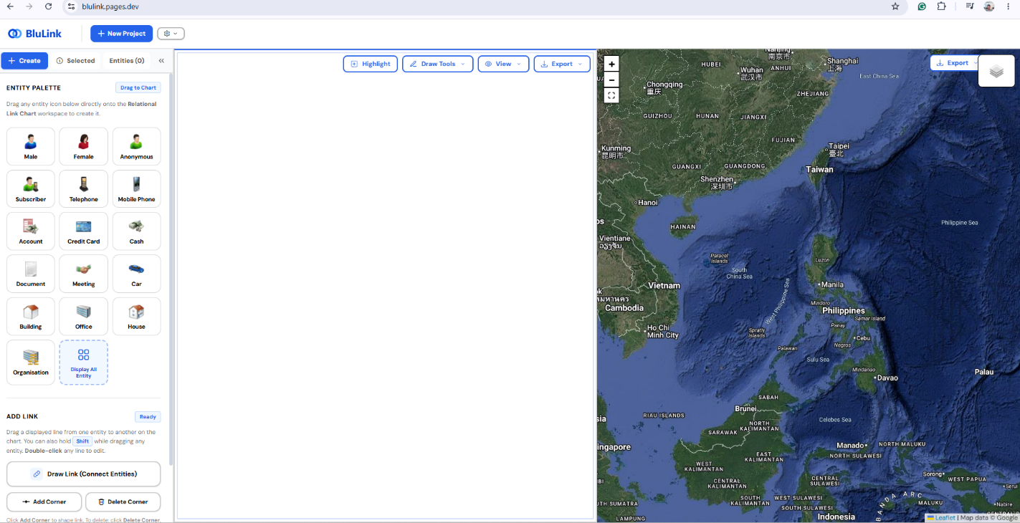

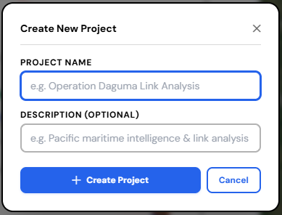

Figure 1.0: Click "New Project" on the top navigation bar. Enter a descriptive investigation title (e.g., Operation Trident - Cartel Tracking) and confirm creation

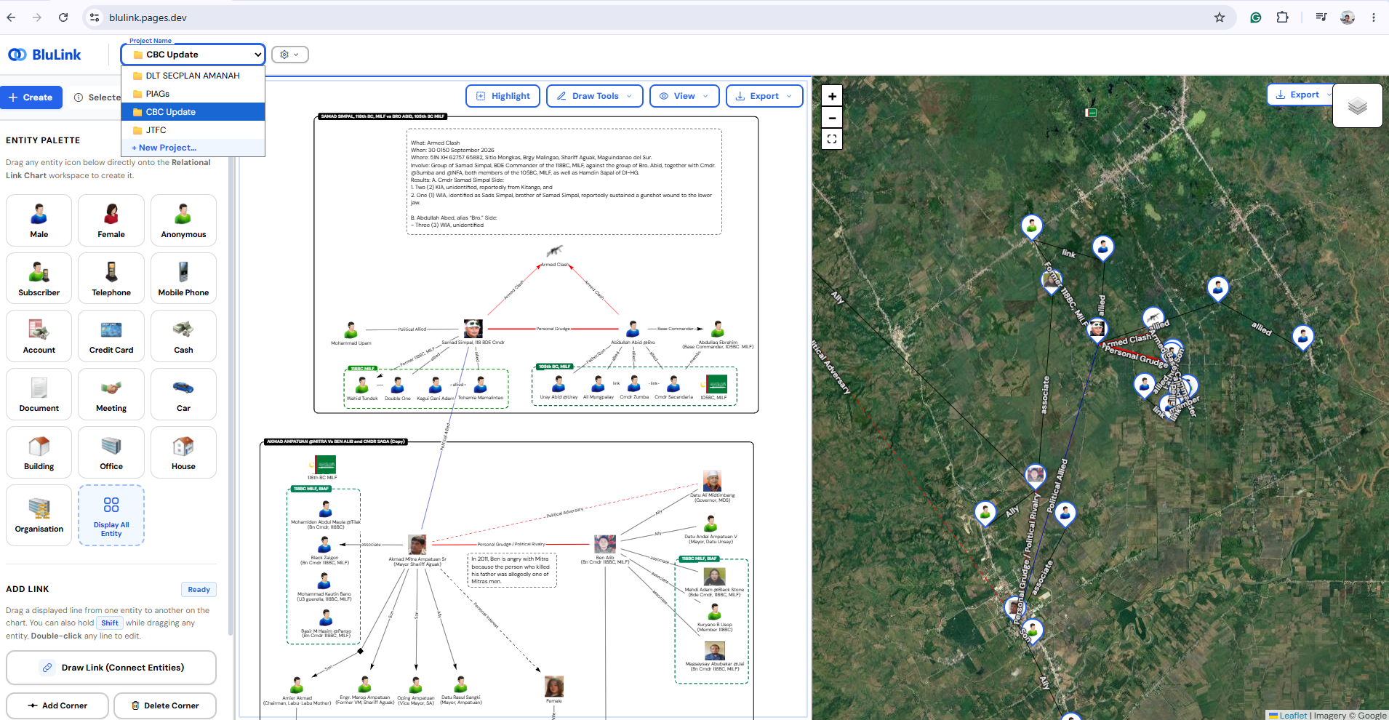
Figure 1.1: Click the active project dropdown to instantaneously switch between open cases. All graph positions and map bounds are auto-restored.

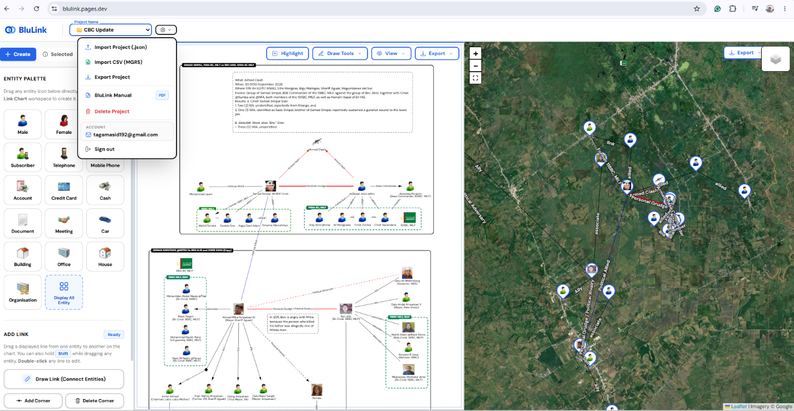
Figure 1.2: Cloning Project from another User’s. Click the settings icon above, then import project.

The Dual-Pane Workspace Interface
03

The BluLink interface is engineered for high situational awareness. It eliminates window switching by presenting both logical relationship structures and physical geographic coordinates simultaneously.

Workspace Layout Anatomy
- Left Pane — Link Analysis Canvas: Interactive node-and-edge network chart. Allows drag-and-drop entity arrangement, multi-segment link routing, container zoning, and live marquee selection.
- Center Splitter Bar: Draggable divider allowing analysts to resize the Link Chart and Map panes to any desired ratio (e.g., 70% Map / 30% Graph for tactical tracking).
- Right Pane — Geospatial Map: High-resolution Leaflet map displaying real-time entity markers, spiderfied clusters, link vectors, and coordinate indicators.
- Left Sidebar: Collapsible tool drawer with 5 dedicated tabs:
  - Palette: Categorized icons ready to drag or click into the chart.
  - Inspect: Detailed profile, GPS/MGRS coordinates, and metadata of the selected entity.
  - List: Searchable tabular directory of all entities and links in the current project.
  - Settings: Map defaults, basemap selection, and visualization preferences.

  - Screen Control Buttons

Tool | Shortcut | Operational Effect
Fit View | Button / Menu | Automatically centers and scales the link chart to display all entities with optimal margins.
Full Screen (Chart) | Button / Esc | Expands the link chart to occupy 100% of the monitor display for conference briefings.
Full Screen (Map) | Map Control | Expands the satellite geospatial map to full screen for spatial route planning.
Toggle Sidebar |   Ctrl + B | Hides or reveals the analytical sidebar to maximize available canvas area.

Entity Management & Profiling
04

Entities represent persons, vehicles, facilities, weapons, organizations, communications, or contraband under active investigation.
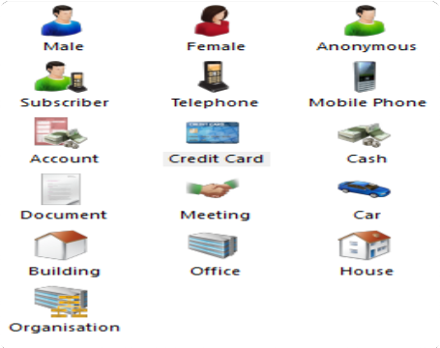

Figure 4.1: BluLink Comprehensive Entity Palette with intelligence icon library.

Adding Entities to the Workspace
- Method A (Drag & Drop): Open the Palette tab in the sidebar. Select an icon category, then click and drag the icon directly onto any desired location on the Link Chart canvas.
- Method B (One-Click Placement): Click on any entity in the Palette or "All Entities" modal; it will be automatically instantiated at the center of the current chart view.
- Method C (Custom Entity): Click "Add Custom Entity" to upload custom PNG/SVG/GIF icons, assign custom category tags, and input initial intelligence notes.

Selected Entity Identifier
VISUAL SELECTION INDICATOR (V1.2 FEATURE)
When an entity is selected, it displays clean solid gray corner framing brackets (┌ ┐ └ ┘) with corner handle marks positioned precisely at the four corners of the entity icon. It contains zero background fill and no full dashed border, preserving 100% icon clarity and visual focus.

Geographic & MGRS Coordinates
Every entity can be assigned physical geographic coordinates. BluLink features an embedded real-time coordinate converter supporting:
- Decimal Degrees (GPS): Latitude (e.g., 14.599512) and Longitude (e.g., 120.984222).
- Military Grid Reference System (MGRS): Standard NATO 10-figure grid precision (e.g., 51RUH1829414210). Typing GPS auto-computes MGRS; typing MGRS auto-computes GPS.

- Interactive Map Picker ( Pick on Map ): Click the crosshair tool in the Inspector panel, then click anywhere on the satellite map to instantly snap the entity's location.

Relationship & Link Analysis
05

Links represent interpersonal communications, financial transfers, operational meetings, logistics supply chains, or familial associations between entities.
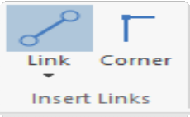

Figure 5.1: Live connection mode linking target entities with directional flow.

Creating Relationship Links
- Quick Draw Mode: Open the Draw Tools dropdown and select Draw Link (or hold entity). Click and release on the destination entity or container box.
Shift

and drag directly from any

- Two-Click Mode: In Draw Link mode, click once on the source node, then click once on the target node.

Link Attributes & Directionality
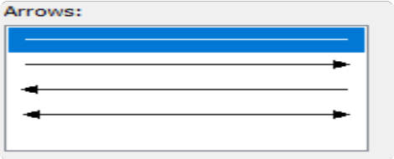

Figure 5.2: Link properties dialog for strength, style, width, and arrows.
Double-click any link line on the chart (or polyline on the map) to open the Edit Link Modal:
- Relationship Label: Contextual text (e.g., "Satellite Phone Call (34 mins)", "Funds Transfer $50,000").
- Link Strength: Confirmed (solid), Suspected (dashed), or Weak (dotted).
- Directional Arrows: None (undirected association), Forward (➔), Backward (⬅), or Bidirectional (⬌).
- Color & Stroke Width: Fully customizable color palette and stroke thickness (1px to 8px).

Multi-Segment / Polyline Routing (Diamond Corners)
To prevent messy line crossings in complex graphs, BluLink supports draggable polyline corners:
- Add Corner: Open Draw Tools ➔ Add Corner. Click on any link segment to insert a draggable diamond handle (◆). Drag the diamond to route the connection cleanly around other clusters.
- Delete Corner: Select Draw Tools ➔ Delete Corner and click any diamond handle (or select the diamond and press
Delete ).

Geospatial Intelligence & Mapping Engine
06

The right pane delivers high-performance tactical mapping powered by Leaflet GIS and Google Maps tiles.

Basemap Layers
Analysts can switch basemaps instantaneously via the map layer control:
- Google Hybrid (Default): High-resolution satellite imagery overlaid with road vectors and place names.
- Google Satellite: Pure satellite reconnaissance imagery for terrain and obstacle assessment.
- Google Terrain: Topographic elevation contours, physical terrain features, and elevation relief.
- Google Tactical: High-contrast dark tactical military HUD basemap engineered for low-light command operations. When selected, standard black relationship links automatically adapt to luminous white for maximum readability.
- Esri Tactical: World Topographic Tactical basemap featuring high-contrast inverted contour lines, elevation relief, waterways, and military physical geography. Automatically adapts black relationship links to luminous white.

Co-Location Clustering & Spiderfy
When multiple entities share the exact same location (e.g., multiple suspects arrested in the same safehouse), BluLink prevents marker overlap by automatically engaging a radial spiderfy cluster upon click. Each entity fans out in a circle with a direct tether to the true ground coordinate.

Synchronized Geospatial Links
Whenever a relationship link exists between two entities with geographic coordinates, BluLink automatically renders a vector polyline between their map pins. The line features:
- Exact synchronized color, thickness, and dash style matching the network chart (black links dynamically adapt to luminous white on Google Tactical and Esri Tactical basemaps).
- Angle-Aligned Floating Text: The relationship label is dynamically rotated and positioned parallel to the vector line angle for seamless geospatial reading.

Grouping, Containers & Annotation Boxes
07

To represent jurisdictional perimeters, suspect cells, military task forces, or operational zones, BluLink provides intelligent container boxes.

Group Boxes & Text Annotations
- Group Boxes: Boundary containers with customizable dashed/solid borders, background color fill opacity (0% to 100%), and corner title badges (e.g., "Suspect Cell Alpha", "Northern Operations Area").
- Text Boxes: Word-wrapped multiline text placards for analytical commentary, date/time stamps, or executive summary text directly on the canvas.

Hierarchical Nesting (Boxes Inside Boxes)
SMART DEPTH HIERARCHY (V1.2 FEATURE)
BluLink features a sophisticated area-based hierarchical hit-testing and rendering engine. When smaller boxes or entities are placed inside a larger container box:
The larger container box renders in the deepest background layer.
Clicking or double-clicking an inner box targets the innermost box directly. The inner box can be edited, resized, and duplicated without interference from the larger parent box.
Clicking on the parent box's border, header badge, or empty padding selects the parent box.

Interactive Selection Pills
When any container box is selected, three dedicated one-click action pill buttons appear immediately above its top-right corner:
- ✎ Edit Box: Opens the modal to modify title, border width, dash style, fill color, and dimensions.
- ⎘ Duplicate: Clones the box with identical properties and styles.
- 🔓 Ungroup: Instantly dissolves the container box while preserving all entities and links inside intact.

Multi-Selection, Marquee & Batch Operations
08

Analyzing large datasets requires batch operations to group, move, or delete collections of entities and links simultaneously.

Multi-Selection Techniques





A Mouse Highlight Tool
Click Highlight in the chart header toolbar or sidebar. Drag anywhere across the canvas to draw a translucent highlight marquee that selects all enclosed entities, boxes, and lines.
B Direct Mouse Highlighting
Drag with the Right Mouse Button or hold Shift while
dragging with the left mouse button to instantly highlight and select entities, boxes, and lines on demand.
C Shift / Ctrl + Click
Hold Shift or Ctrl while clicking on individual entities, boxes,
or lines to toggle their selection state without deselecting other items.
D Select All & Clear
Press Ctrl + A to select everything in the workspace. Press
Esc or click on empty canvas to deselect.

Group Moving & Dragging
When multiple entities and/or group boxes are highlighted or selected:
- Real-Time Synchronized Dragging: Clicking and dragging any one of the highlighted entities or boxes smoothly moves all selected items together across the canvas while preserving their relative layout, spacing, and connection geometry.
- Workspace Boundary Clamping: Multi-drag operations respect safety workspace borders, keeping all dragged nodes within visible analytical view bounds.
  - Unified & Cross-Project Clipboard ( Ctrl+C , Ctrl+X , Ctrl+V )

Analysts can rapidly replicate or relocate multi-item graph clusters within a project or across separate investigative projects:
C


- Cross-Project Copy & Paste: Highlight entities in Project A, press
Ctrl
+
, switch to Project B via the project

dropdown, and press local storage.
Ctrl
+ V . The clipboard persists across project switches, tab changes, and browser reloads via

- Automatic Direct Connection to Matching Entities: When pasting entities into a project:
  - If any pasted entity has the same name as an entity already existing in the destination project, BluLink automatically establishes a Direct Link connecting them directly.
  - If the copied entities had relationships in the source project to neighboring entities whose names exist in the target project, BluLink automatically connects them directly to those existing nodes as well.
- Cut ( Ctrl+X ): Copies the highlighted cluster to the clipboard and removes the entities, boxes, and associated links from the workspace with full undo snapshot protection.
- Duplicate ( Ctrl+D ): Directly duplicates the active selection in a single keystroke.

  - Grouping ( Ctrl+G )
When two or more items (entities, boxes, or links) are selected:

- Press
Ctrl
+
(or open the Draw Tools dropdown and click Group Selected).


- BluLink calculates the exact bounding box enclosing all selected items, adds standard 28px padding, and wraps them in a new Group Box automatically.
G
  - Ungrouping ( Ctrl+Shift+G / Ctrl+U )

To dissolve a group box without deleting the records inside:
Shift
G
Ctrl

- Select the Group Box (or select any entity inside it) and press
Ctrl
+
+
or
+ U .

- Alternatively, click the 🔓 Ungroup pill button above the box or in the Edit Box modal footer.
- The container box is safely removed; all entities, icons, links, and coordinates remain completely intact.

History, Undo/Redo, Import & Export
09

Undo & Redo Architecture
BluLink records every workspace mutation into an in-memory chronological state stack:
- Undo ( Ctrl+Z ): Steps back one operation (supports entity deletion, link creation, box resizing, grouping, and coordinate changes).
Ctrl+Y
- Redo ( or Ctrl+Shift+Z ): Re-applies the previously undone state.

Exporting Analytical Products
Completed link and geospatial charts can be exported for tactical intelligence briefings, GIS mapping systems, and court evidentiary presentations via the unified Export dropdown in both the Workstation and Geospatial Map toolbars:

Format | Output Target | Recommended Operational Use & Interoperability
Save as PDF | Vector Document (.pdf) | Formal intelligence dossiers, tactical briefs, and court-ready exhibits with crisp vector typography.
Save as CSV | Spreadsheet Table (.csv) | UTF-8 BOM encoded spreadsheet with Name, Type, Alias, Latitude, Longitude, MGRS, Notes, Connections, and Connection Count. Directly opens in Excel, ArcMap (Add XY Data), ArcGIS Pro, and QGIS.
Image (PNG) | Ultra-HD Raster (.png) | Lossless high-resolution briefing slides, PowerPoint presentations, printed intelligence summaries, and operational case files.
Image (JPEG) | Compressed Raster (.jpeg) | Lightweight visual snapshots optimized for field radio transmissions, web publishing, and bandwidth-constrained channels.
Export Project | JSON Package (.json) | Full forensic backup containing all entities, link topologies, custom coordinates, and group boxes. Restorable across any BluLink terminal.

Restoring Workspace from Backup
To restore or share a project, click "Import Project" in the project settings menu. Select the .json file; BluLink verifies schema integrity, updates nodes and links, recalculates MGRS grids, and mounts the workspace immediately.

Importing Entities & MGRS Coordinates from CSV
To batch-import intelligence records, field targets, safehouses, or GPS/MGRS coordinates into your current project:
- Click "Import CSV (MGRS)" in the Project Settings Menu (top navigation) or click "Import CSV" in the Entities Directory tab in the left sidebar.
- Drag and drop your .csv spreadsheet or click to browse your file.
- BluLink automatically scans and detects columns such as Name, Type, MGRS, Latitude, Longitude, and Notes.
- Automatic MGRS Conversion: Every MGRS grid string (e.g. 51PTS8284914993) is decoded into standard WGS-84 decimal latitude and longitude using BluLink's military grid conversion engine.
- Click "Import Entities":

- All entities are placed onto the Workstation Link Chart, arranged cleanly across the canvas.
- All entities with valid MGRS coordinates are immediately plotted as interactive tactical pins on the Geospatial Map, with the map automatically zooming to fit all coordinates.

Keyboard Shortcuts & Operations Matrix
10

Power users can navigate, model, and analyze intelligence records rapidly using the following standardized keyboard accelerators:

Shortcut | Function | Context & Behavioral Notes
  Ctrl + G | Group Selected | Wraps 2 or more selected entities, boxes, or links into an enclosing container box.
    Ctrl + Shift + G | Ungroup Box | Dissolves the container box while preserving all internal entities and links.
Ctrl + U | Ungroup Box (Alt) | Alternative one-hand shortcut to dissolve the selected group box.
  Ctrl + A | Select All | Selects every entity, box, and link in the current workspace.
Shift + Click | Multi-Select Item | Toggles an individual entity, box, or link in the active selection set.
Shift + Drag | Marquee Drag-Select | Draws a rubberband selection rectangle on empty canvas to batch-select items.
      Ctrl + Z | Undo Action | Reverts the last graph, box, coordinate, or link modification.
Ctrl + Y | Redo Action | Re-applies the most recently undone workspace state.
Ctrl + C | Copy Selected | Copies selected entities, internal links, or boxes into the BluLink clipboard.
      Ctrl + X | Cut Selected | Copies selection to clipboard and removes them from the canvas.
Ctrl + V | Paste Clipboard | Pastes items from clipboard with automatic 40px visual offset.
Ctrl + D | Duplicate Selected | One-step duplicate for selected entity, text box, or container box.
  Enter or F2 | Edit Selected Item | Opens the edit modal for the currently selected container box or text box.
  Delete / Backspace | Delete Selected | Deletes selected entities, links, boxes, or diamond corner handles.
Ctrl + B | Toggle Sidebar | Expands or collapses the left analytical drawer.
Esc | Escape / Cancel | Cancels active drawing modes, closes modals, exits full screen, and clears selection.

Operational Troubleshooting & FAQs
11

Q1: Why does an entity not appear on the geospatial map?
Resolution: The entity must have valid geographic coordinates. Select the entity, open the Inspect tab in the sidebar, and

confirm that both Latitude and Longitude are populated. You can also click coordinates.
Pick on Map

Q2: Can I edit an inner box when it is covered by a larger container box?
and click the map directly to assign

Resolution: Yes! BluLink v1.2 incorporates an intelligent hierarchical hit-testing engine. Simply double-click directly inside the inner box or on its border to open its edit modal. To edit the outer parent box, double-click on the parent box's title badge or outside the boundary of the inner box.

Q3: What coordinate precision does the MGRS converter support?
Resolution: BluLink includes a specialized military grid library (mgrs.min.js) that computes standard 10-figure MGRS grids, providing 1-meter ground resolution accuracy for tactical military and defense operations.

Q4: Does ungrouping a box delete the entities or relationship links inside?
Resolution: No. Ungrouping safely dissolves only the visual container boundary box. All entities, icons, links, attributes, and geospatial coordinates remain completely untouched.

Q5: How do I export a high-resolution chart without UI buttons for presentations?
Resolution: Click the Export dropdown in the top action bar and select Export Image (PNG). The system renders a clean, transparent or solid-background high-dpi canvas screenshot excluding all menus, banners, and toolbars.

BluLink Intelligence Analysis Workspace • Developed by Rawnald Blu • Official Operational Documentation For technical inquiries or deployment updates, visit https://blulink.pages.dev/

